*Heaven’s light is our guide.*

*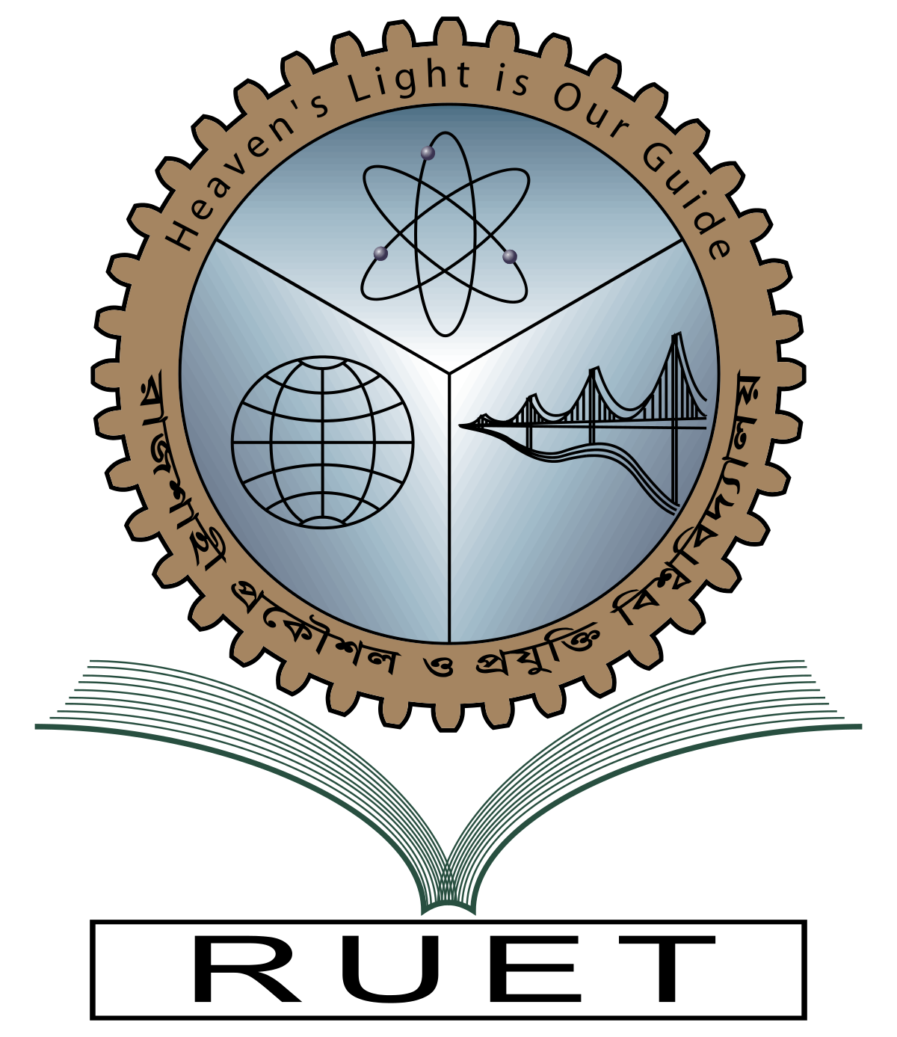***Rajshahi University of Engineering and Technology**

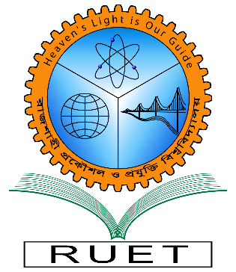

**Department of Electrical & Electronic Engineering**

**ASSIGNMENT**

**Course no.** EEE3109

**Course title:** Computational Methods in Electrical Engineering

**Topic:** Bisection method & False Position Method

**Date of submission:** March 22,2022.

|  |  |
| --- | --- |
| **Submitted to:** | **Submitted by:** |
| **Dr. Md. Masud Rana**  **Professor**  Dept. of Electrical & Electronic Engineering,  Rajshahi University of Engineering and Technology. | **Ashraf Al- Khalique**  **Roll:** 1801171  **Session:** 2018-2019  Dept. of Electrical & Electronic Engineering,  Rajshahi University of Engineering and Technology. |